**פרויקט גמר אינטראקציית אדם סוכן**

תמיר שמואלי

ישראלה מגירה

**אוניברסיטת בר אילן**

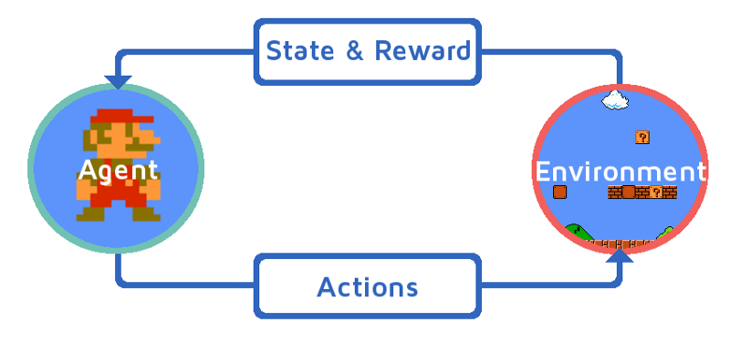

התנהגות אנשים במשחקי "נתינה" ו"לקיחה"

האם ניתן לחזות התנהגות אנשים במשחקים לאור החלטותיהם במשחקים דומים?

|  |  |  |
| --- | --- | --- |
| Game behavior: |  |  |
| CDG_CHOICE | Number of chips TAKEN by participant in Commons Dilemma Game (0-40) |  |
| CDG_CHOICE_R | RECODE of Commens Dilemma (40 minus CDG_CHOICE) |  |
| Specific motive scales: |  |  |
| CDG_fairness | Participant's mean score based on the three individual Fairness items (asked after the Commons Dilemma) |  |
| CDG_altruism | Participant's mean score based on the three individual Altruism items (asked after the Commons Dilemma) |  |
| CDG_socwelfare | Participant's mean score based on the three individual Social Welfare items (asked after the Commons Dilemma) |  |
| CDG_concernothers | Participant's mean score based on the three individual Concern for Others items (asked after the Commons Dilemma) |  |
| CDG_greed | Participant's mean score based on the three individual Greed items (asked after the Commons Dilemma) |  |
| CDG_competition | Participant's mean score based on the three individual Compeitiveness items (asked after the Commons Dilemma) |  |
| CDG_entitlement | Participant's mean score based on the three individual Entitelement items (asked after the Commons Dilemma) |  |
| General motivational factors: |  |  |
| CDG_factor_prosocial | Extracted PROSOCIAL factor (based on the inter-correlations among the 21 motivational items -- asked after the Commons Dilemma) |  |
| CDG_factor_proself | Extracted PROSELF factor (based on the inter-correlations among the 21 motivational items -- asked after the Commons Dilemma) |  |
|  |  |  |
|  |  |  |
| **\*\* Prefix "PGDG" refers to Public Goods Dilemma Game** |  |  |
| Game Behavior: |  |  |
| PGDG_CHOICE | Number of chips GIVEN by participant in Public Goods Dilemma Game (0-40) |  |
| Specific motive scales: |  |  |
| PGDG_fairness | Participant's mean score based on the three individual Fairness items (asked after the Public Goods Dilemma) |  |
| PGDG_altruism | Participant's mean score based on the three individual Altruism items (asked after the Public Goods Dilemma) |  |
| PGDG_socwelfare | Participant's mean score based on the three individual Social Welfare items (asked after the Public Goods Dilemma) |  |
| PGDG_concernothers | Participant's mean score based on the three individual Concern for Others items (asked after the Public Goods Dilemma) |  |
| PGDG_greed | Participant's mean score based on the three individual Greed items (asked after the Public Goods Dilemma) |  |
| PGDG_competition | Participant's mean score based on the three individual Compeitiveness items (asked after the Public Goods Dilemma) |  |
| PGDG_entitlement | Participant's mean score based on the three individual Entitelement items (asked after the Public Goods Dilemma) |  |
| General motivational factors: |  |  |
| PGDG_factor_prosocial | Extracted PROSOCIAL factor (based on the inter-correlations among the 21 motivational items -- asked after the Public Goods Dilemma) |  |
| PGDG_factor_proself | Extracted PROSELF factor (based on the inter-correlations among the 21 motivational items -- asked after the Public Goods Dilemma) |  |
|  |  |  |
|  |  |  |
| **\*\* Prefic "BG" refers to Bandit Game** |  |  |
| Game behavior: |  |  |
| BG_CHOICE | Number of chips TAKEN by participant in Bandit Game (0-100) |  |
| BG_CHOICE_R | RECODE of Bandit Game (100 minus BG_CHOICE) |  |
| Specific motive scales: |  |  |
| BG_fairness | Participant's mean score based on the three individual Fairness items (asked after the Bandit Game) |  |
| BG_altruism | Participant's mean score based on the three individual Altruism items (asked after the Bandit Game) |  |
| BG_socwelfare | Participant's mean score based on the three individual Social Welfare items (asked after the Bandit Game) |  |
| BG_concernothers | Participant's mean score based on the three individual Concern for Others items (asked after the Bandit Game) |  |
| BG_greed | Participant's mean score based on the three individual Greed items (asked after the Bandit Game) |  |
| BG_competition | Participant's mean score based on the three individual Compeitiveness items (asked after the Bandit Game) |  |
| BG_entitlement | Participant's mean score based on the three individual Entitelement items (asked after the Bandit Game) |  |
| General motivational factors: |  |  |
| BG_factor_prosocial | Extracted PROSOCIAL factor (based on the inter-correlations among 16 of the 21 motivational items -- asked after the Bandit Game) = Model B |  |
| BG_factor_proself | Extracted PROSELF factor (based on the inter-correlations among 16 of the 21 motivational items -- asked after the Bandit Game) = Model B |  |
| *Note. The three altruism items and the first two concern for others items had their primarily loadings on the wrong factor and were therefore discarded from the analysis in Model B.* |  |  |
|  |  |  |
|  |  |  |
| **\*\* Prefix "DG" refers to Dictator Game** |  |  |
| Game behavior: |  |  |
| DG_CHOICE | Number of chips GIVEN by participant in Dictator Game (0-100) |  |
| Specific motive scales: |  |  |
| DG_fairness | Participant's mean score based on the three individual Fairness items (asked after the Dictator Game) |  |
| DG_altruism | Participant's mean score based on the three individual Altruism items (asked after the Dictator Game) |  |
| DG_socwelfare | Participant's mean score based on the three individual Social Welfare items (asked after the Dictator Game) |  |
| DG_concernothers | Participant's mean score based on the three individual Concern for Others items (asked after the Dictator Game) |  |
| DG_greed | Participant's mean score based on the three individual Greed items (asked after the Dictator Game) |  |
| DG_competition | Participant's mean score based on the three individual Compeitiveness items (asked after the Dictator Game) |  |
| DG_entitlement | Participant's mean score based on the three individual Entitelement items (asked after the Dictator Game) |  |
| General motivational factors: |  |  |
| DG_factor_prosocial | Extracted PROSOCIAL factor (based on the inter-correlations among the 21 motivational items -- asked after the Dictator Dilemma) |  |
| DG_factor_proself | Extracted PROSELF factor (based on the inter-correlations among the 21 motivational items -- asked after the Dictator Dilemma) |  |
|  |  |  |

פירוט המשחקים השונים:

הדיקטטור:

מורכב בדרך כלל משני אנשים, שאחד מהם מקבל כסף מסוים. לאינדיבידואל השני אינו מקבל דבר. למשתתף שהעניק את הכסף, הידוע בניסוי "הדיקטטור", נאמר שהוא צריך להציע למשתתף השני סכום מסוים של כסף זה, אפילו אם הסכום הזה הוא אפס. יש לקבל את הסכום אותו מציע הרודן למשתתף השני. המשתתף השני, אם ימצא שהסכום אינו מספק, אז לא יוכל להעניש את הרודן בשום דרך. [3] 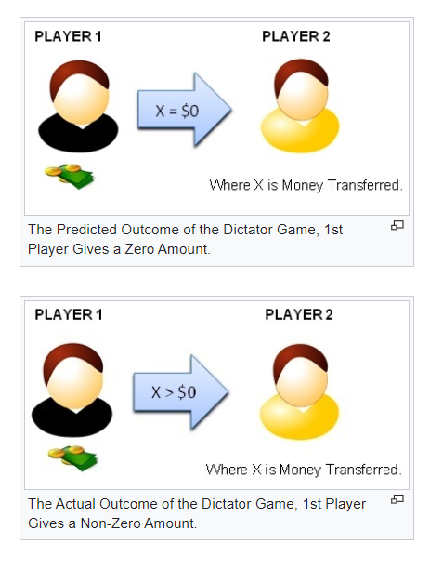

Rules

|  |  |  |
| --- | --- | --- |
| DG.CHOICE | BG.CHOICE.R | PGDG.CHOICE |
| '(28-32]' | '(90-inf)' | 66.66666667 |
| '(-inf-4]' | '(90-inf)' | 16.66666667 |
| '(32-36]' | '(90-inf)' | 27.5 |
| '(12-16]' | '(90-inf)' | 50 |
| '(36-inf)' | '(90-inf)' | 61.55555556 |
| '(16-20]' | '(80-90]' | 50 |
| '(36-inf)' | '(80-90]' | 50 |
| '(24-28]' | '(80-90]' | 75 |
| '(24-28]' | '(70-80]' | 40 |
| '(16-20]' | '(70-80]' | 50 |
| '(28-32]' | '(70-80]' | 30 |
| '(36-inf)' | '(70-80]' | 46.14285714 |
| '(32-36]' | '(70-80]' | 50 |
| '(4-8]' | '(60-70]' | 30 |
| '(28-32]' | '(60-70]' | 50 |
| '(32-36]' | '(60-70]' | 45 |
| '(12-16]' | '(50-60]' | 9 |
| '(28-32]' | '(50-60]' | 51.5 |
| '(8-12]' | '(50-60]' | 40 |
| '(16-20]' | '(50-60]' | 35 |
| '(36-inf)' | '(50-60]' | 47.5 |
| '(-inf-4]' | '(40-50]' | 51 |
| '(32-36]' | '(40-50]' | 50 |
| '(4-8]' | '(40-50]' | 45 |
| '(20-24]' | '(40-50]' | 40 |
| '(24-28]' | '(40-50]' | 50 |
| '(12-16]' | '(40-50]' | 43.57142857 |
| '(28-32]' | '(40-50]' | 48.09090909 |
| '(16-20]' | '(40-50]' | 43.65 |
| '(8-12]' | '(40-50]' | 39.1 |
| '(36-inf)' | '(40-50]' | 49.13636364 |
| '(28-32]' | '(30-40]' | 100 |
| '(36-inf)' | '(30-40]' | 15 |
| '(12-16]' | '(30-40]' | 40 |
| '(16-20]' | '(30-40]' | 35.5 |
| '(8-12]' | '(20-30]' | 1 |
| '(24-28]' | '(20-30]' | 46 |
| '(16-20]' | '(20-30]' | 45 |
| '(36-inf)' | '(20-30]' | 50 |
| '(24-28]' | '(10-20]' | 19 |
| '(36-inf)' | '(10-20]' | 75 |
| '(-inf-4]' | '(-inf-10]' | 2.25 |
| '(8-12]' | '(-inf-10]' | 5 |
| '(4-8]' | '(-inf-10]' | 6 |
| '(36-inf)' | '(-inf-10]' | 22.33333333 |
| '(16-20]' | '(-inf-10]' | 11.1 |

|  |  |
| --- | --- |
|  |  |
| **\*\* Prefix "CDG" refers to Commons Dilemma Game** |  |
| Game behavior: |  |
| CDG_CHOICE | Number of chips TAKEN by participant in Commons Dilemma Game (0-40) |
| CDG_CHOICE_R | RECODE of Commens Dilemma (40 minus CDG_CHOICE) |
| Specific motive scales: |  |
| CDG_fairness | Participant's mean score based on the three individual Fairness items (asked after the Commons Dilemma) |
| CDG_altruism | Participant's mean score based on the three individual Altruism items (asked after the Commons Dilemma) |
| CDG_socwelfare | Participant's mean score based on the three individual Social Welfare items (asked after the Commons Dilemma) |
| CDG_concernothers | Participant's mean score based on the three individual Concern for Others items (asked after the Commons Dilemma) |
| CDG_greed | Participant's mean score based on the three individual Greed items (asked after the Commons Dilemma) |
| CDG_competition | Participant's mean score based on the three individual Compeitiveness items (asked after the Commons Dilemma) |
| CDG_entitlement | Participant's mean score based on the three individual Entitelement items (asked after the Commons Dilemma) |
| General motivational factors: |  |
| CDG_factor_prosocial | Extracted PROSOCIAL factor (based on the inter-correlations among the 21 motivational items -- asked after the Commons Dilemma) |
| CDG_factor_proself | Extracted PROSELF factor (based on the inter-correlations among the 21 motivational items -- asked after the Commons Dilemma) |
|  |  |

פרויקט גמר אינטראקציית אדם סוכן

לצורך כך נעזרנו בתוכנה Weka וקיבלנו את התוצאות הבאות עבור K-mean clustering , שם הרצנו

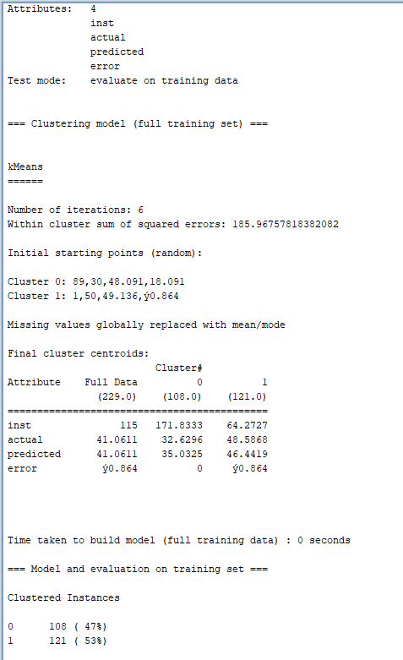

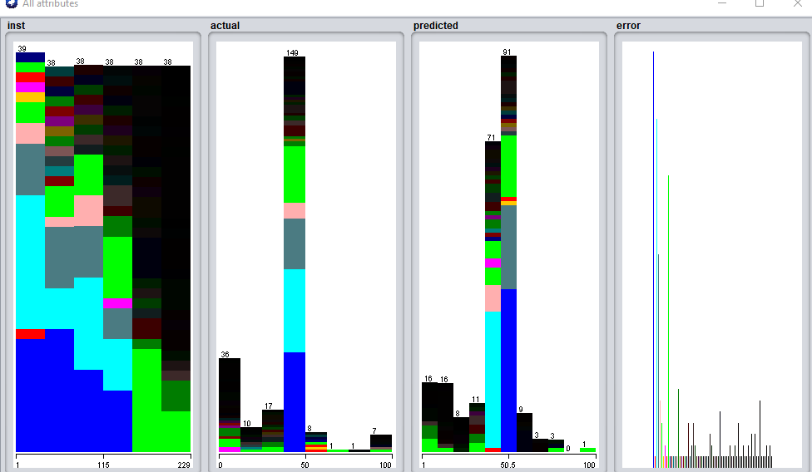 סיכום התוצאות,   
את התנהגותם של המדדים הבאים:

Isnt

Actual

Presicted

error

e

כותרת איורים:

visualize

